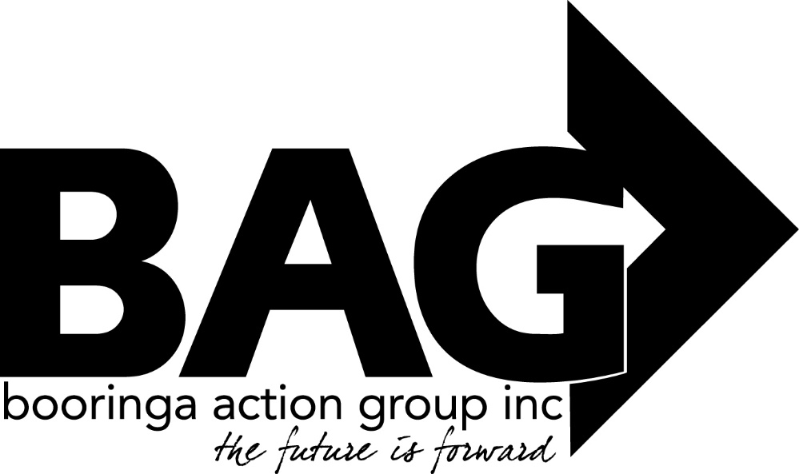

Minutes of the General Meeting of the Booringa Action Group Inc. held at the Shire Hall on Thursday September 15, 2022 commencing at 5.30 P.M.
Attendance Mr Rob Cornish chaired the meeting with Jeff Watson, Rob and Sandra Cornish, Barbara Brennan, Donna McCarrol, Ross Halpin, David Anderson, Hazel Wang, Seamus Batstone, Kylie Millar, Crs John Birkett and Geoff McMullen, John Ford, Craig Hilly, Alan and Pat Beggs, Kel and Tilly Woodall and Wayne Mills
Apologies
Moved S. Cornish Seconded B. Brennan
“That apologies be received and leave of absence be granted for this meeting for Mayor Tyson Golder, Crs Julie Guthrie, Mark Edwards, George Ladbrook, Cameron O’Neill, Wendy Taylor and Jo Hancock, Jane Fenton, Jaden Ball, Bernadette Stanton and Darryl Betzien.
2.0 Confirmation of Minutes
Moved R. Halpin Seconded H. Wang
“That the minutes of the General Meeting held on August 18, 2022 as circulated be confirmed” Carried 17/0
- Correspondence
Inwards Correspondence:
Maranoa Regional Council
Proposing the following points for a combined BAG/Council Christmas Shop Campaign for 2022.
- “The campaign will commence beginning of November and run for a month in the lead up to both the Maranoa Christmas Street Party and BAG’s Christmas in the Park celebration – where the draw will take place.
- All entries into the local draw (1 x ticket per purchase of $10) will automatically be entered into the regional draw (at no extra cost to BAG or local businesses)Entry will be via paper based tickets
- Council will print all flyers and ticketing
- Tickets from all local areas will be brought to Roma for the regional draw at the Maranoa Christmas Street Party and then returned to their respective areas for the local draws.
- We anticipate having the T & C’s drafted and confirmed within the next week and will send you a copy for your review
- We’d also like to have all prizes and donating businesses confirmed by beginning of October. This follows two weeks to design, compile and get approvals for all marketing collateral and then another two weeks to get the printing (tickets, flyers etc) completed and distributed across the region
Copies of marketing collateral and tickets will be provided to BAG for approval, prior to any printing”
Jane will provide further information of this initiative
Maranoa Regional Council
Providing a letter of support for the funding application by council to extend development of the Tourism Precinct adjacent to the swimming pool.
Moved J. Watson Seconded J. Ford
“That the Inwards Correspondence be received and the Outwards Correspondence be endorsed” all in favour CARRIED 17/0
4.0 Financial Report
Moved J. Watson Seconded B. Bennan
”That the Financial Report for the September 2022 meeting be received subject to audit” all in favour Carried 17/0
4.1 List of Payments
Moved J. Watson Seconded R. Halpin
“That the List of Payments for August 2022 as contained in the Financial Report be approved” all in favour Carried 17/0
- Officers Report
Total visitation since commencing operations – 193,982. Bree and Dee have completed the Community Drought Resilience course. A morning tea and discussion on a drought Hub will be held on November 2.
A verbal report was given to cover/discuss
- EV Charging Station Mitchell – Seamus to chase up with local service stations
- Drought resilience workshops – Mitchell – November 2
- Riverwalk Projection Workshop
- RADF Community Workshops
- Staff Qualifications - renewed again
- Qld Information Centres conference – Noosa – October 4 – 6
RESQ are holding 3 workshops – Paper, Scissors Paint, Recycling Rustic Revamp, and Junk
Moved J. Watson Seconded H. Wang
“That the Officers Report for the September 2022 meeting be received” all in favour Carried 17/0
General Business
FOG report
John Ford presented his report – John judged the Art for Arts Sake display currently showing at the Library. Due to wet weather John was unable to attend a very successful meeting on Monday. 2 full days of workshops called Creative Arts Odyssey are being planned, John will bring this up at the next meeting. Rob thanked John for his report.
Director Seamus presented a comprehensive report on major project updates and big issues of Council locally. Thanks go to Seamus for this report.
Kylie Miller told the Meeting she has looked into whether the tennis courts would be accessible in later years under another Principal. She is to meet with BAG to fill out a contract.
Cr John Birkett told the Meeting of a suggestion made to him by Robin Mansfield that sculptures be built by our towns’ artists and placed along the river walk and other strategic places, to add to the tourism attractions of the town.
Moved R Halpin Seconded B. Brennan
“BAG write to Ann Leahy asking her to question ‘why can’t we have a junior Doctor here, working under the supervision of Telehealth?’ all in favour CARRIED
Next Meeting: The date of the next meeting will be October 22 unless otherwise advised
Closure: There being no further business the Chairman closed the meeting at 7.06pm and thanked all for their attendance.

Chairman……………………………. Date……………………………..

