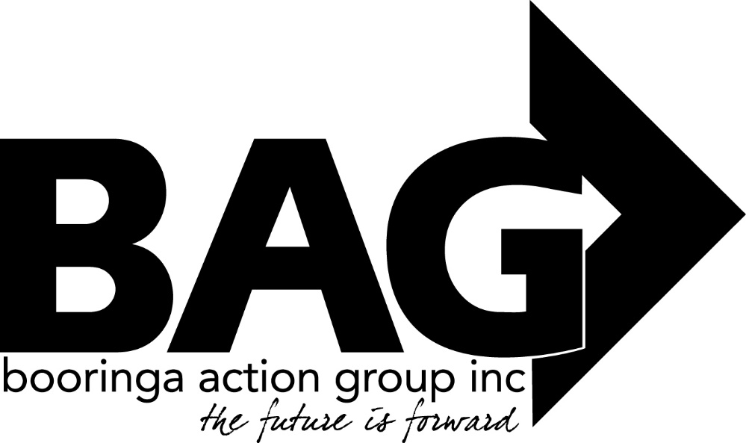

Minutes of the General Meeting of the Booringa Action Group Inc. held at the Mitchell Shire Hall on Thursday April 21, 2022 commencing at 5.30 P.M.

Attendance Mr Rob Cornish chaired the meeting with Jeff Watson, Rob and Sandra Cornish, Barbara Brennan, Donna McCarrol, Darryl Betzien, John Ford, Ross Halpin, Dee Schafer, B. Stanton, Dean Ellwood, Crs John Birkett, Geoff McMullen and Julie Guthrie, Jane Fenton and Jayden Ball in attendance. The Acting Manager of the Mitchell Motel attended at 6:00pm.
- Apologies
Moved S. Cornish Seconded R. Halpin
“That apologies be received and leave of absence be granted for this meeting for Mayor Tyson Golder, Hazel Wang, Edwina Marks and Cr George Ladbrook”
Carried 16/0

2.0 Confirmation of Minutes
Moved J. Ford Seconded B. Brennan
“That the minutes of the General Meeting of the Booringa Action Group Inc. held on 17 February 2022 as circulated be confirmed”
Carried 16/0
- Correspondence: Inwards:
Maranoa Regional Council Advising that:
- “an audit of existing parking signage in the CBD that aims to help communicate expected parking discipline has been undertaken; and
- a draft a signage plan aimed at improving signage/communication has been prepared.
Council’s Deputy Director/Strategic Road Management, Strategic Road Management and Contract Management Office will now prepare a report to Council regarding implementation.”
Richard Kirkman – Mitchell Motel
Advising that he is currently seeking development approval for the relocation of the Rail Carriage to the Motel grounds. Once approval is forthcoming, he will be in a position to negotiate lease conditions with Booringa Action Group.
Moved R. Halpin Seconded B. Stanton
“ BAG authorize the Management Committee to negotiate a lease agreement with Richard Kirkman”
Carried 16/0
Moved J. Watson Seconded S. Cornish
“That the Inwards Correspondence for the April 2022 meeting be received”
Carried 16/0
Outwards Correspondence: No Outwards Correspondence
- Financial Report
Moved J. Watson Seconded B. Brennan
“That the Financial Report for the April 2022 meeting be received subject to audit”
Carried 16/0
4.1 List of Payments
Moved J. Watson Seconded R. Halpin
“That the List of Payments for March 2022 as contained in the Financial Report be approved”
Carried 16/0
- Officers Report
Jeff presented the Officers Report for the month, visitation has increased substantially. Investigations have been ongoing to have the new Community Bus “wrapped” for promotional purposes. The can be done in Charleville which is by far the best option given its relatively close proximity. While we have yet to finalize a quote, an upper limit of $4,000.00 has been set for the project. Various designs have been considered with the most appealing being a Spa image on the driver’s side and a composite of the Maranoa Library (bull sculpture) and the Booringa Heritage Museum on the other side. The back of the vehicle would be given over to an image of the Kenniff statues.
Moved J. Watson Seconded B.Stanton
“BAG proceed with the wrapping of the bus as described” Carried 17/0
The cottage has been vandalized (windows broken) but, because of its rudimentary construction, remains otherwise fully sound. This cottage was retained by BAG with a view to renovating it into emergency/crisis accommodation. At present, RESQ+ have a resident supervisor who is a qualified builder and would be happy to undertake the renovation work as a RESQ+ project (which was, in any case, the original plan). RESQ+ still retains a small number pf CDEP participants who would work with the supervisor on the project. Given that this is a relatively small window pf opportunity, BAG is asked to consider having priority item repairs (at the minimum) undertaken. If we can successfully complete the priority items, it may be possible to secure some grant funding for the interior fit out.
Moved J. Ford Seconded B. Brennan
“BAG organise RESQ+ to proceed with repairs to the building one estimates are finalized”
Carried 17/0
River Walk The River Walk is, at the moment, overgrown. This is the result of the lack of personnel available through RESQ+ who have traditionally maintained the track for BAG. Given our responsibility for the maintenance of this important community asset, discussions have been held with the management of RESQ+ in an attempt to resolve this situation. One possible solution is offer some form of remuneration for the time involved in the required maintenance. RESQ+ is happy to support this approach with the provision of mowing and slashing equipment. Additionally, at least one CDEP participant has expressed interest in being involved in such a proposal A similar arrangement is currently in place in Cunnamulla.
Staff Training Bree has been accepted into the Drought Resilience Leaders Development Program South West Qld.
Staff Updates/Upskilling Ken Chandler will also be providing the following training for staff. Pool lifeguard full course – Tuesday 24 & Wednesday 25 May. Pool operations course – Tuesday 26 May & Friday 27 May.
- General Business FOG John Ford presented his report, the 100 years of CWA display is now on, there is a morning tea tomorrow to celebrate the occasion. Another exhibition is coming up, it is hoped that a plan can be organised to bring displays from the other galleries in the district, to Mitchell. Any type of artwork can be exhibited, it doesn’t have to be paintings.
New Director MRC Chairman Rob introduced Dean Ellwood to the Group. Dean will be taking Normans place until a permanent position is determined.
Airstrip: Sandra Cornish expressed concern that the RFDS Chief Pilot has said the airstrip at Mitchell is not long enough for their new planes to land here. Dean is to follow this problem up. RFDS also needs to know of any airstrips on properties in the district, please let them know.
Water Tower: Darryl Betzien suggested a laser system be used instead of a mural on the water tower.

Closure:
There being no further business the Chairman closed the meeting at 7.16pm and thanked everyone for their attendance, especially the Councillors.
Next Meeting:
The date of the next meeting will be May 19 unless otherwise advised.

Chairman……………………………. Date……………………………..

