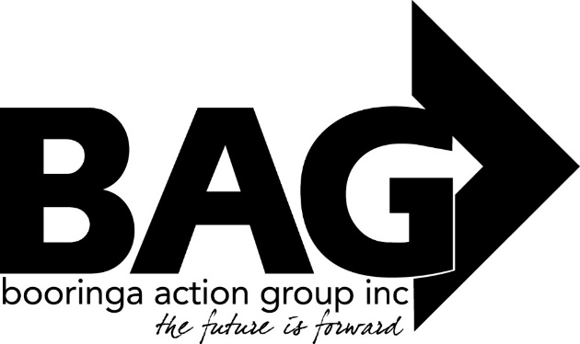
Minutes of the General Meeting of the Booringa Action Group Inc, held at the Cottage on Thursday 19 September, 2019
Open: Chairman Rob declared the Meeting open at 5.46pm, and welcomed everyone.
Attendance: Mr Rob Cornish chaired the meeting with Jeff Watson, John Ford, Donna McCarrol, Darryl Betzien, Kerrol Blackett, Bree Jiggins and Hazel.
Apologies:
Moved D. Betzien Seconded J. Ford
“That apologies be received and leave of absence be granted for this meeting for Barbara Brennan, Crs Geoff McMullen and Jan Chambers, and John Birkett.” Carried 8/0
- Confirmation of Minutes
Moved J. Ford Seconded K. Blackett
“That the minutes of the General Meeting of the Booringa Action Group Inc. held on July 18, 2019 as circulated, be confirmed” Carried 8/0
- Correspondence
Moved B. Jiggins Seconded J. Watson
“That the Inwards Correspondence be received, and the Outwards Correspondence for July/August 2019 be endorsed.” Carried 8/0
Inwards Correspondence
Maranoa Regional Council – Australia Day Nominations – Jane Fenton
“Please have a think of some outstanding achievements made during the year by young people, active community members, sporting awards for both junior and adult categories, community member contributions, perhaps you have been in a committee who coordinated an outstanding event? The list goes on! Australia Day 2020 will be upon us before we know it. Please nominate to celebrate those outstanding achievements within our community.”
Outwards Correspondence
Gaming Community Benefit Fund – Community Bus
BAG has submitted another application for the community bus under the Gambling Community Benefit Fund Round 102
4.0 Financial Report
Moved J. Watson Seconded B. Jiggins
“That the Financial Report for the July/August 2019 meeting be received subject to audit” Carried 8/0
4.1 List of Payments
Moved J. Watson Seconded K. Woodall
“That the List of Payments for July/August 2019 as contained in the Financial Report be approved” Carried 8/0
- Officer’s Report
Moved J. Watson Seconded K. Blackett
That the Officers Report for July/August 2019 be received” Carried 8/0
A Verbal Report will be presented covering the following:
- Great Artesian Spa – July/August Report
- Information Centre/Accreditation
- John Murray Memorial
- BAG Calendar
- Booringa Fire and Water Festival
Great Artesian Spa – Wednesday Roast Nights are going well good feedback, good numbers No internet at the Spa for 9 weeks, thanks to Jeff for allowing the Spa to use his wifi. Natalie Buitendag has commenced her traineeship. Accreditation application has been completed and sent off. John Murray Memorial – opened on 13 August BAG Calendar – information forwarded to Gigi Booringa Fire and Water Festival 90 booked for camp oven dinner Friday night. Saturday starts at 12 noon at the Show Grounds, $10.00 entry fee for Over 17 yo, stalls 12 – 5pm. Thanks to Rotary for a donation of drought relief money, this will help with costs. Joyce Hughes provided BAG with a list of ex-patriots whose response to BAGs invite was wonderful. Jeff expressed his gratitude to both Cara Cicero and Bree for their work organizing the Fire and Water Festival, without this work the Festival would not have happened.
General Business: Friends of the Gallery
President of the Group, John Ford delivered his report; John welcomed Jeff back after his recent illness, he also expressed his concern at the low number of people attending BAG meetings.
The auction of art work and paintings was very well represented, 50 paintings went to auction with an average of $52 per painting being achieved. The Group is developing a 5 year plan. A new art display is now at the Gallery, this has been described as the ‘best’ display so far. The battle with getting suitable lighting goes on. Janelle has organised a full calendar of displays for the 2020 year, these dates will be on the new calendar. Kerrol reported that she and Madeliene Cobb will be visiting both schools to teach 3D drawing to interested kids.
Mt Moffatt trip: John gave a report on the recent trip to Mt Moffatt. Thanks go to Mayor Tyson Golder and his family for their excellent work as hosts for the venture. The few days were fantastic and the documentary will be sent to BAG when completed.
President Rob thanked John for his input. A big thank you also goes to Darryl, Ross and Liz for their efforts in operating the bus for the season, much appreciated! Jeff told the Group that a Community Service guy is looking for something meaningful he could do to fulfil his Community Service obligations, suggestions to Jeff.
Sunnybank Hills Rotary Club are looking for a project in Western Qld, could anyone think of a project costing around $5,000.00 that we could nominate?
Next Meeting: Thursday 24 October, 2019 at 5.30pm at the Cottage unless otherwise determined.
Close: No further business, President Rob closed the Meeting at 7.21pm and thanked everyone for coming.
President……………………………………………… Date…………………………….

